Report - Server Side Events

In this report, I have described code along with explanation of the implementation both locally and remotely.

Joining the nodes in distributed hash table to communicate between them.

Used listenOn, listenOff and listeners to communicate between them,

Adding and retrieving bindings at both locally and remotely.

**CODE:**

In POM file, server.name property has been defined (local/home) and jar file generates after run the project at specified location.

<properties>

<project.build.sourceEncoding>UTF-8</project.build.sourceEncoding>

<!-- HTTP server listens on this port. -->

<server.port.http>8080</server.port.http>

<!-- External DNS for AWS. -->

<server.external-dns>localhost</server.external-dns>

<!-- Where to distribute jar files (using mvn package). -->

<server.home>${user.home}</server.home>

<server.testdir>${server.home}/tmp/cs549/dht-test</server.testdir>

<server.dist>${server.testdir}</server.dist>

<server.name>dht</server.name>

</properties>

In Application file, register the server side events.

**public class** Application **extends** ResourceConfig {

**public** Application() {

**super**(NodeResource.**class**, SseFeature.**class**);

packages("edu.stevens.cs549.dhts.resource");

// **TODO** register SseFeature

}

}

In WebClient class file, we put listenForBinding and listenOff methods. ListenForBinding tells another node that whatever changes happen to any particular key, whichever node binds to that key will be notified.

**public** EventSource listenForBindings(NodeInfo node, **int** id, String skey) **throws**

DHTBase.Failed {

// **TODO** listen for SSE subscription requests on http://.../dht/listen?key=<key>

// On the service side, don't expect LT request or response headers for this request.

// Note: "id" is client's id, to enable us to stop event generation at the server.

String uri = String.*format*(node.addr + UriApi.*LISTEN*, id, skey);

WebTarget target = listenClient.target(uri);

EventSource eventsrc = **new** EventSource(target, **false**);

**return** eventsrc;

}

ListenOff method is useful to get disconnect from node to given key. ListenOff to node will no longer eligible to get notified.

**public void** listenOff(NodeInfo node, **int** id, String skey) **throws**

DHTBase.Failed {

// **TODO** listen for SSE subscription requests on http://.../dht/listen?key=<key>

// On the service side, don't expect LT request or response headers for this request.

String uri = String.*format*(node.addr + UriApi.*LISTEN*, id, skey);

**try** {

deleteRequest(**new** URI(uri));

} **catch** (Exception e) {

**throw new** DHTBase.Failed("listenOff error. message: " + e);

}

}

deleteRequest and putRequest methods:

**public** Response putRequest(URI uri, Entity<?> entity) {

// **TODO** Complete.

**try**{

Response cr = client.target(uri)

.request(MediaType.***APPLICATION_XML_TYPE***)

.header(Time.***TIME_STAMP***, Time.*advanceTime*())

.put(entity);

processResponseTimestamp(cr);

**return** cr;

} **catch** (

Exception e) {

error("Exception during Put request: " + e);

**return null**;

}

}

**public** Response deleteRequest(URI uri) {

Response cr = client.target(uri)

.request(MediaType.***APPLICATION_XML_TYPE***)

.header(Time.***TIME_STAMP***, Time.*advanceTime*())

.delete();

processResponseTimestamp(cr);

**return** cr;

}

In State class file added addlisteners and remove listeners methods. Which adds if map contains the key into the node.

@Override

**public void** addListener(**int** id,String key,EventOutput eventopt) {

**if**(outputs.containsKey(id)){

outputs.get(id).put(key, eventopt);

} **else** {

Map<String,EventOutput> map = **new** HashMap<String,EventOutput>();

map.put(key,eventopt);

outputs.put(id,map);

}

**if**(listeners.containsKey(key)){

listeners.get(key).add(eventopt);

} **else** {

Map<String,EventOutput> map = **new** HashMap<String,EventOutput>();

SseBroadcaster b = **new** SseBroadcaster();

b.add(eventopt);

listeners.put(key,b);

}

}

Simply remove nodes form the node in hash table.

**public void** removeListener(**int** id, String key) {

// **TODO** Close the event output stream.

**if**(listeners.containsKey(key)){

listeners.get(key).remove(outputs.get(id).get(key));

}

}

listenOn and listenOff methods in Dht class file.

This method register a new node for new bindings. Client send request to identify this node.

**public void** listenOn(String key, EventListener listener) **throws** DHTBase.Failed {

**int** id = *NodeKey*(key);

NodeInfo succ = **this**.findSuccessor(id);

EventSource eventsrc = client.listenForBindings(succ, info.id, key);

state.addCallback(key, eventsrc);

eventsrc.register(listener);

eventsrc.open();

}

This method stops listening to binding the node.

**public void** listenOff(String key) **throws** DHTBase.Failed {

**int** id = *NodeKey*(key);

NodeInfo succ = **this**.findPredecessor(id);

client.listenOff(succ, info.id, key);

state.removeCallback(key);

}

**Local Test:**

ListenOn, listenOff and listeners command to communicate in has table between nodes.

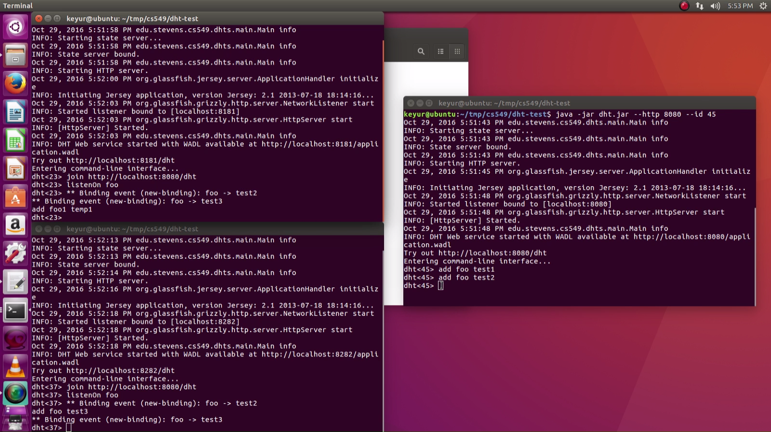

**Remote Test:**

Transfer dht.jar file on amazon ec2 instance using Secure Copy (Scp) and connect that instance using Secure Shell (SSH).

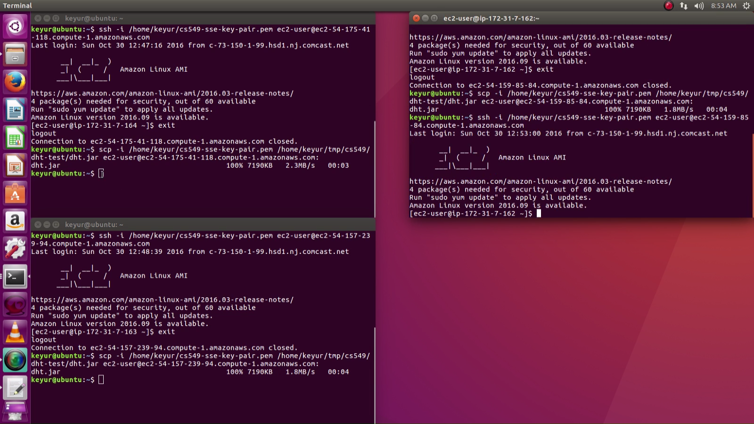

On Ec2 instances, three nodes perform DHT commands.

